let's look at xxx (ticker: xxx). show me its revenue mix by business segments, and who's their top competitors in each of all segments, and use a table to summarize your answer, and highlight who're public companies. please update your answer based on the link here https://www.sec.gov/ix?doc=/Archives/edgar/data/0001481582/000095017025024199/ryi-20241231.htm
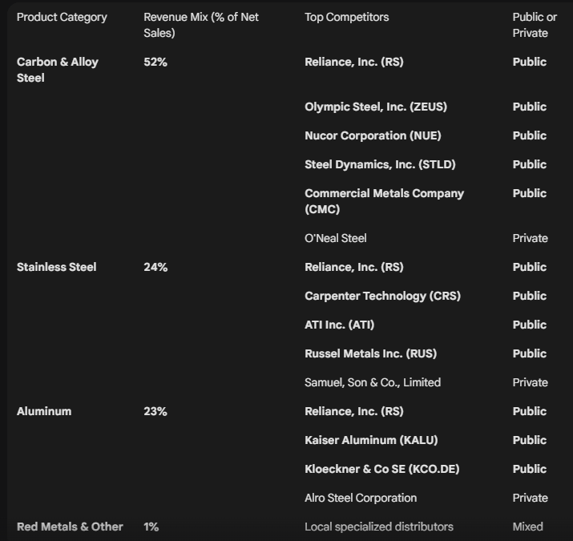

can you look at the credit agreement with XXX at the link below? i need to know the answers to questions 1) who are lenders? 2) what's the size of facilities and their maturity date, any sublimit(s)? 3) any accordion terms? 4) pricing grids or applicable rates? 5) any borrowing base related information, 6) any amortization schedule for term loans, 7) any financial covenants, 8) any mandatory repayments arrangements 9) any permitted indebtedness, 10) any restricted payments, 11) any restrictions on acquisition / disposition, 12) any covenant-related definition on terms such as EBITDA. please summarize your answers for each question one by one.
https://www.sec.gov/Archives/edgar/data/1041859/000104185925000015/plce-ex106x11125.htm

